

Tribhuvan University
Faculty of Humanities and Social Sciences
Kirtipur, Kathmandu

A Lab Report
On
Programming Logic & Techniques using Python (MCA504)

Submitted by
Name: Bishal Rijal

Submitted to
Roshan Tandukar

Patan Multiple Campus
Patandhoka, Lalitpur

Department of MC
Affiliated to Tribhuvan University

Roshan Tandukar

………………...

May- 2026

Assignment 1
1. Assume we have 10 US dollars & 25 Saudi Riyals. Write a Python Script to convert the total currency to Nepali Rupees. (Exchange rates: 1 US Dollar = 133.72 NRs and 1 Saudi Riyal = 35.82 NRs) 1
2. Given the initial deposit, the annual interest rate, and the number of years that you invest your money in an investment account. Calculate the final amount of the investment using math.pow() function. 1
3. Write a program to find root of the equation 4x**2 -21x + 25=0 using the formula x = (-b ± √(b² - 4ac)) / 2a 2
4. Write a program to take “gender” as input from user. If the user is male, give the message: Good Morning Sir. If the user is female, give the message: Good Morning Ma’am. 2
5. Write a program to take input color of road traffic signal from the user & show the message according to this table: 3
6. Write a program that takes user input day name. If the day is Monday, Tuesday, Wednesday, Thursday or Friday, then show “It’s a week day”. If the day is Saturday then show “It’s weekend”. If the day is sunday then show “Yay! It’s a holiday”. 4
7. Use a conditional (ternary) operator for this exercise: 5
If the variable age is a value below 18, the value of the variable voteable should be "Too young", otherwise the value of voteable should be "Old enough". 5
8. Write a program to take input the marks obtained in three subjects & total marks. Compute & show the resulting percentage on your page. Take percentage & compute grade as per following table: 6
9. Write a program to repeatedly print the value of the variable num which is input by user. Value should be decreasing by 0.5 each time, as long as x Value remains positive. 7
10. Write a program using for loop that will iterate from 1 to 20. For each iteration, it will check if the current number is even or odd, and report that to the screen (e.g."2 is even"). 7

1. Assume we have 10 US dollars & 25 Saudi Riyals. Write a Python Script to convert the total currency to Nepali Rupees. (Exchange rates: 1 US Dollar = 133.72 NRs and 1 Saudi Riyal = 35.82 NRs)
dollar = 10
riyal = 25
nepali_rupees = (dollar * 133.72) + (riyal * 35.82)
print(f"Total currency in NRs: {nepali_rupees}")

2. Given the initial deposit, the annual interest rate, and the number of years that you invest your money in an investment account. Calculate the final amount of the investment using math.pow() function.

import math
deposit = float(input("Enter the initial deposit: "))
interest_rate = float(input("Enter the annual interest rate (in decimal): "))
years = int(input("Enter the number of years: "))

final_amount = deposit * math.pow((1+ interest_rate), years)
print(f"The final amount of the investment after {years} years is: {final_amount:.2f}")
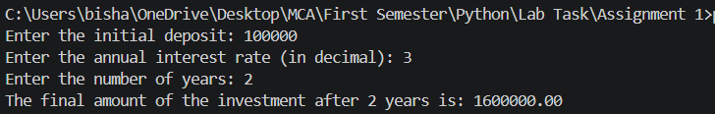

3. Write a program to find root of the equation 4x**2 -21x + 25=0 using the formula x = (-b ± √(b² - 4ac)) / 2a

import math
a = 4
b = -21
c = 25

discriminant = b**2 - 4*a*c
if discriminant > 0:
root1 = (-b + math.sqrt(discriminant)) / (2*a)
root2 = (-b - math.sqrt(discriminant)) / (2*a)
print(f"The roots are real and different: {root1} and {root2}")
elif discriminant == 0:
root = -b / (2*a)
print(f"The roots are real and the same: {root}")
else:
real_part = -b / (2*a)
imaginary_part = math.sqrt(-discriminant) / (2*a)
print(f"The roots are complex: {real_part} + {imaginary_part}i and {real_part} - {imaginary_part}i")

4. Write a program to take “gender” as input from user. If the user is male, give the message: Good Morning Sir. If the user is female, give the message: Good Morning Ma’am.

gender = input("Enter your gender: ")

if gender == "male":
print("Good Morning Sir.")
elif gender == "female":
print("Good Morning Ma’am.")
else:
print("Invalid input. Please enter only male or female.")
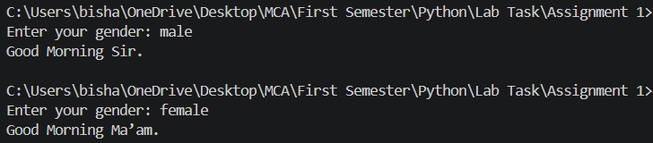

5. Write a program to take input color of road traffic signal from the user & show the message according to this table:
SIGNAL COLOR | MESSAGE
RED | Vehicle must stop
YELLOW | Vehicles should get ready to move
GREEN | Vehicles can move now

signal_color = input("Enter the color of the traffic signal (RED, YELLOW, GREEN): ").upper()
if signal_color == "RED":
print("Vehicle must stop")
elif signal_color == "YELLOW":
print("Vehicles should get ready to move")
elif signal_color == "GREEN":
print("Vehicles can move now")
else:
print("Invalid input. Please enter RED, YELLOW, or GREEN.")

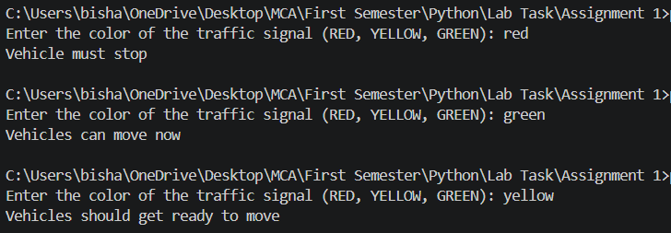

6. Write a program that takes user input day name. If the day is Monday, Tuesday, Wednesday, Thursday or Friday, then show “It’s a week day”. If the day is Saturday then show “It’s weekend”. If the day is sunday then show “Yay! It’s a holiday”.

day = input("Enter the day name: ").upper()
days = ["MONDAY", "TUESDAY", "WEDNESDAY", "THURSDAY", "FRIDAY"]
if day in days:
print("It's a week day")
elif day == "SATURDAY":
print("It's weekend")
elif day == "SUNDAY":
print("Yay! It's a holiday")
else:
print("Invalid day name")
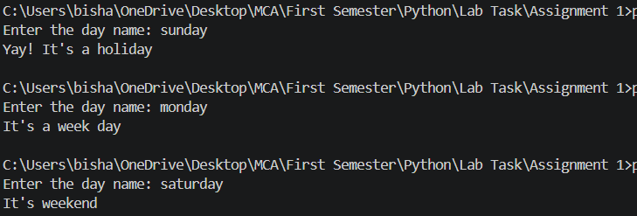

7. Use a conditional (ternary) operator for this exercise:

If the variable age is a value below 18, the value of the variable voteable should be "Too young", otherwise the value of voteable should be "Old enough".

age = int(input("Enter your age: "))

votable = "Too young" if age < 18 else "Old enough"
print(votable)

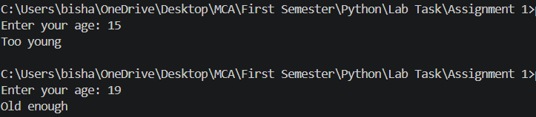

8. Write a program to take input the marks obtained in three subjects & total marks. Compute & show the resulting percentage on your page. Take percentage & compute grade as per following table:

Percentage | Grade | Remarks
Greater than or equal to 80 | A one | Excellent
Greater than or equal to70 | A | Good
Greater than or equal to 60 | B | You need to improve
Less than 60 | Fail | Sorry

marks1 = float(input("Enter marks obtained in subject 1: "))
marks2 = float(input("Enter marks obtained in subject 2: "))
marks3 = float(input("Enter marks obtained in subject 3: "))

total_marks = float(input("Enter total marks: "))

total_obtained = marks1 + marks2 + marks3
percentage = (total_obtained / total_marks) * 100
print(f"Total Marks Obtained: {total_obtained}")
print(f"Percentage: {percentage:.2f}%")

if percentage >= 80:
print("Grade: A-one")
print("Remarks: Excellent")
elif percentage >= 70:
print("Grade: A")
print("Remarks: Good")
elif percentage >= 60:
print("Grade: B")
print("Remarks: You need to improve")
else:
print("Grade: Fail")
print("Remarks: Sorry")
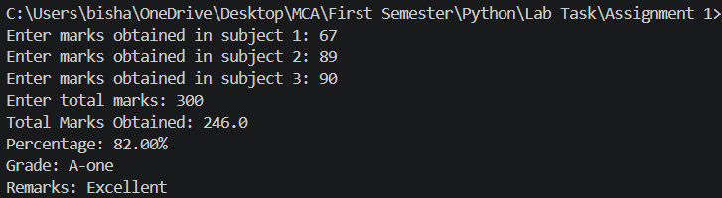

9. Write a program to repeatedly print the value of the variable num which is input by user. Value should be decreasing by 0.5 each time, as long as x Value remains positive.
num = float(input("Enter a positive number: "))
while num > 0:
print(num)
num -= 0.5

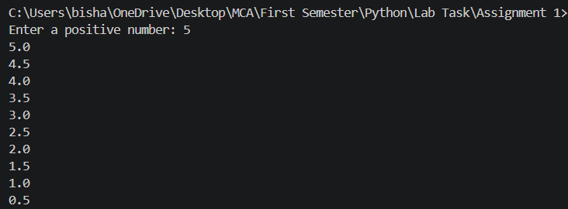

10. Write a program using for loop that will iterate from 1 to 20. For each iteration, it will check if the current number is even or odd, and report that to the screen (e.g."2 is even").
1 is Odd
2 is Even
3 is Odd
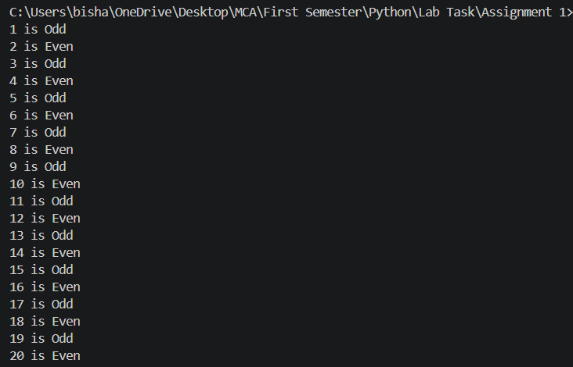
4 is Even
5 is Odd
and so on.

for i in range(1, 21):
if i % 2 == 0:
print(f"{i} is Even")
else:
print(f"{i} is Odd")

